Ayush Thapa

Date of Submission: 08/08/2024

Assignment 1 Data Visualization

Contents

Scenario 1

First Task 1

Policies and Procedures 1

Second Task 2

Excel: GDP 2

Reference 13

## Scenario

The purpose of this report is to analyse the provided ‘The Wealth of Nations’ data from different corners of their businesses, create visualisations and transform the information into meaningful insights for better decision making and business outcomes.

# First Task

## Policies and Procedures

In data analysis, there are several important policies and procedures that need to be followed to get the best results possible. A few of them are:

1. Information/ Data should come from a reliable source: This makes the result/ conclusion genuine and accurate. Or else, we get a fake news kind of scenario.
2. Always check the supplied data: Check the data or table for any mistakes and missing values. If necessary, transform the raw data at hand by using appropriate features such as ‘Power Query’ in MS Excel, to fix minor errors like removing duplicate values, and filling in the missing values, spelling errors, capitalisation, etc. This part is called ‘data cleaning.’
3. Data security: Sensitive data need to be protected by following the company’s proper guidelines and procedures (for e.g. using protected marking schemes: Unrestricted, Restricted, Highly Restricted, etc) to prevent security breaches. **(Twilio Inc. 2024)**
4. Usage: There are times when customer’s approval is needed for data sharing with other third parties. Without the customer’s consent- selling, purchasing or misusing their information and details is technically considered a cybercrime.

So, a data analyst must be aware of such rules and regulations for high-quality data analysis and reporting.

# Second Task

## Excel: GDP

1.

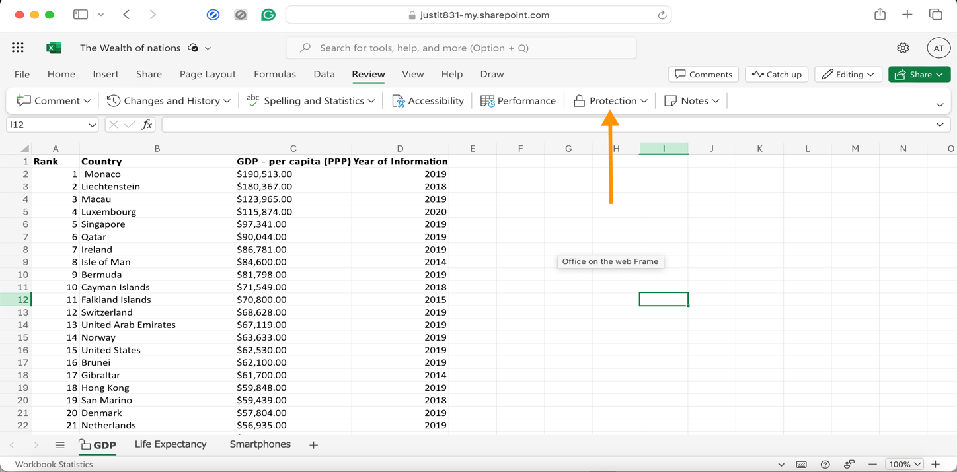

The worksheet was protected by selecting the ‘Protection’ option from the ‘Review’ tab as shown in the screenshot above. (The password is 123).

2.

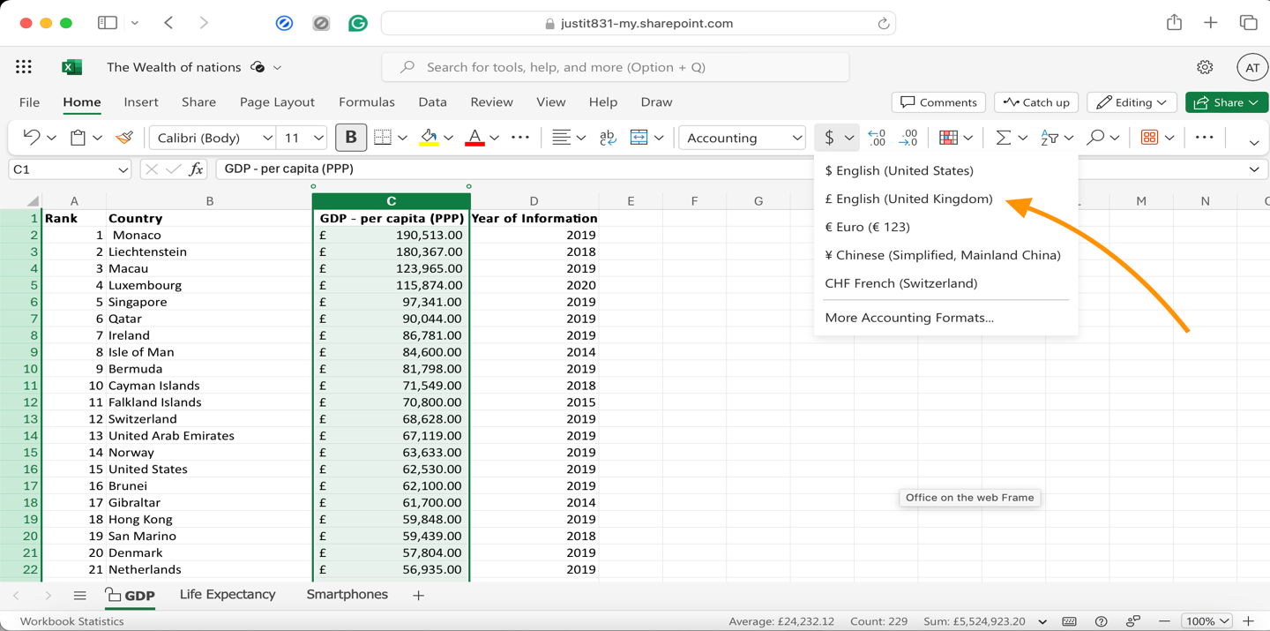

Highlighting the column C, the data was changed to British Pound symbol (£) by selecting the currency option located in the home tab as shown above.

3.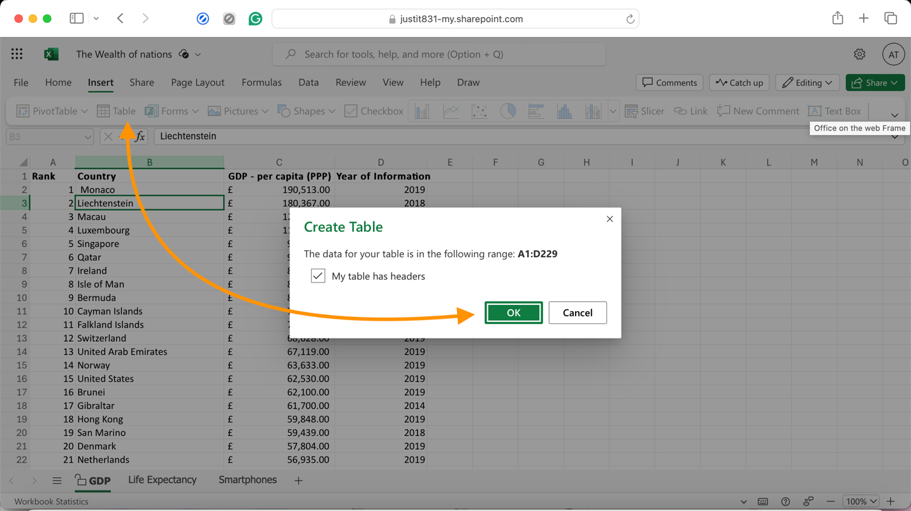

From the ‘Insert’ tab, a table was created by clicking on the ‘Table’ option. This converted the supplied data in the GDP sheet into a table.

4.

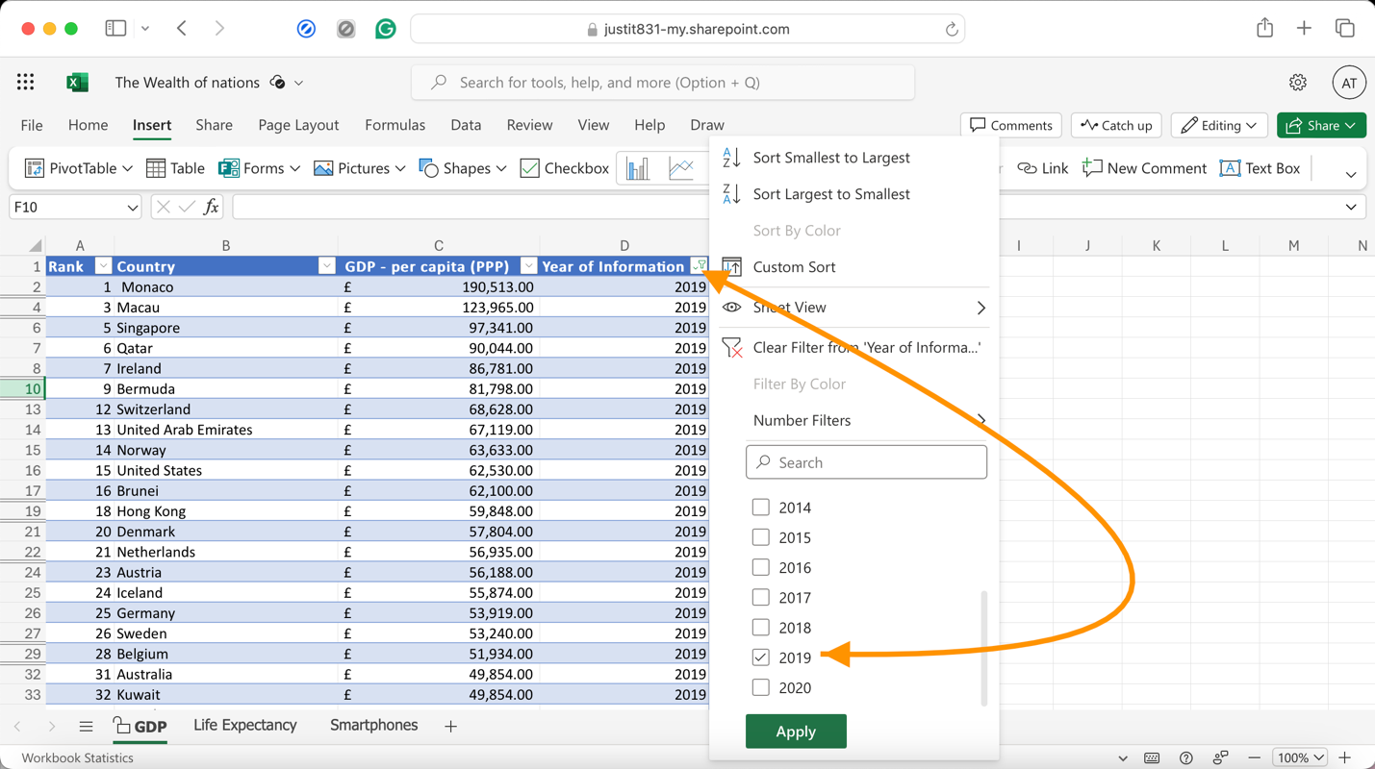

The table created above in the step no. 3 automatically creates a ‘filter’ dropdown option in the table header as displayed in the above picture. From the ‘Year of Information’ column, only ‘2019’ year was selected to display the information.

5.

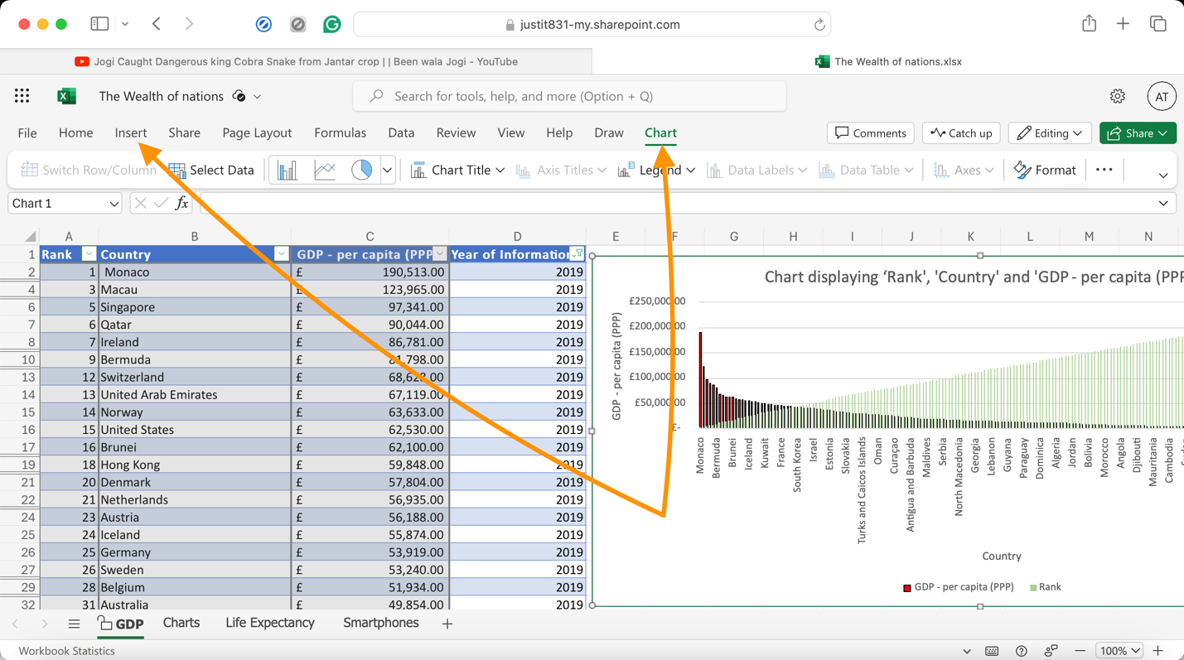

Then, a chart was created to display the following data: ‘Rank,’ ‘Country’ and ‘GDP - per capita (PPP). This was done by going to the Insert tab and then selecting the chart. Column chart was chosen for this data.

All three variables: Rank, Country, and GDP – per capita (PPP) were first drawn on the same graph. And after that, two separate graphs were plotted one showing Rank against each Country and another - GDP against each Country.

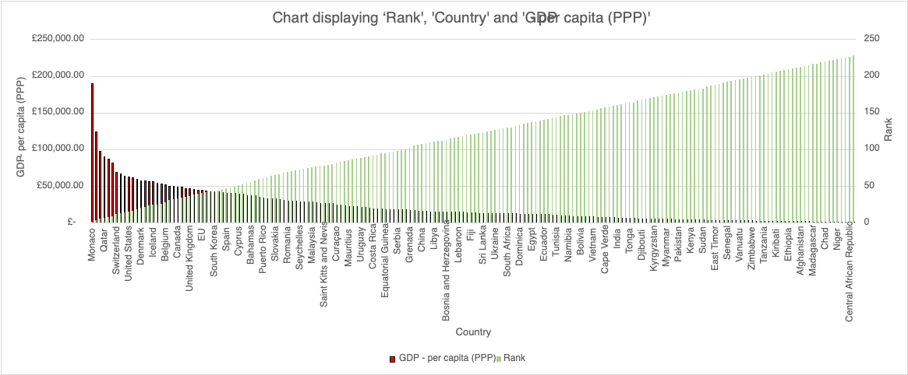

Since the assignment asks us to create a chart that displays three variables namely - ‘Rank,’ ‘GDR per Capita (PPP)’ and ‘Country,’ so a Clustered column chart was drawn to show ‘GDR per Capita (PPP)’ on the primary vertical axis and the ‘Ranks’ on the secondary vertical axis against each ‘country’ on the horizontal axis.

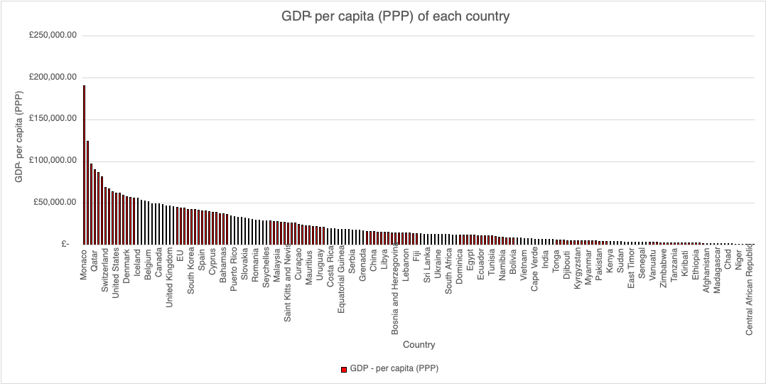

A clustered column chart showing the GDP – per capita (PPP) of each country.

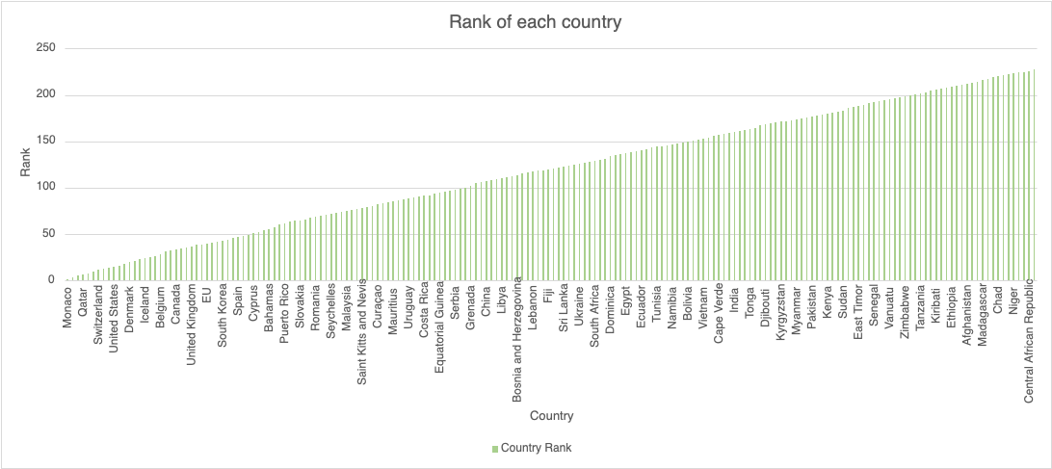

A clustered column chart showing the ranks of each country.

6. All charts were titled and labelled with x and y axis.

7. The three charts were then moved to a new work sheet and named it ‘Charts’.

8.

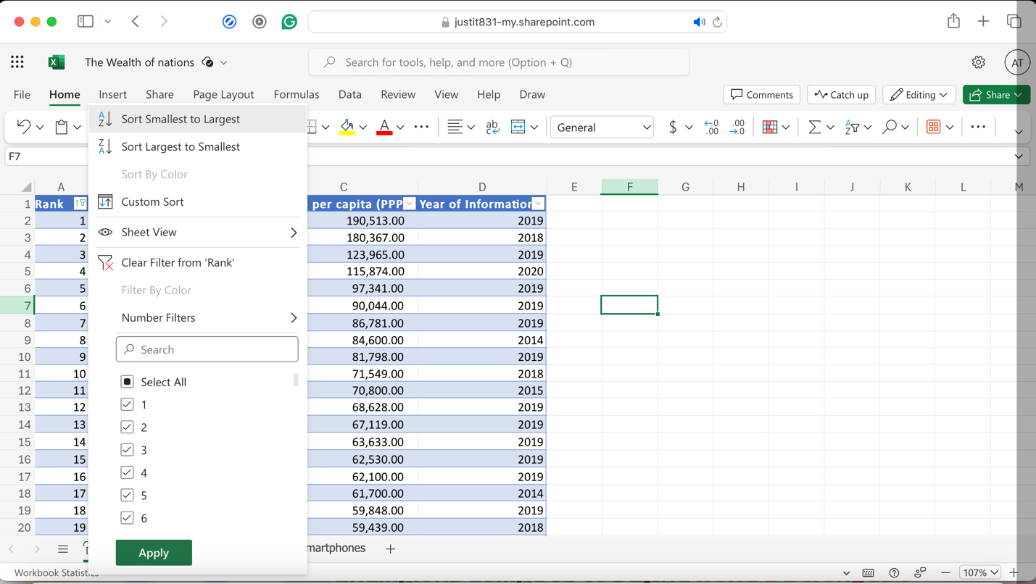

Here, the table was sorted to display the top 20 highest ranking countries on the screen.

9.

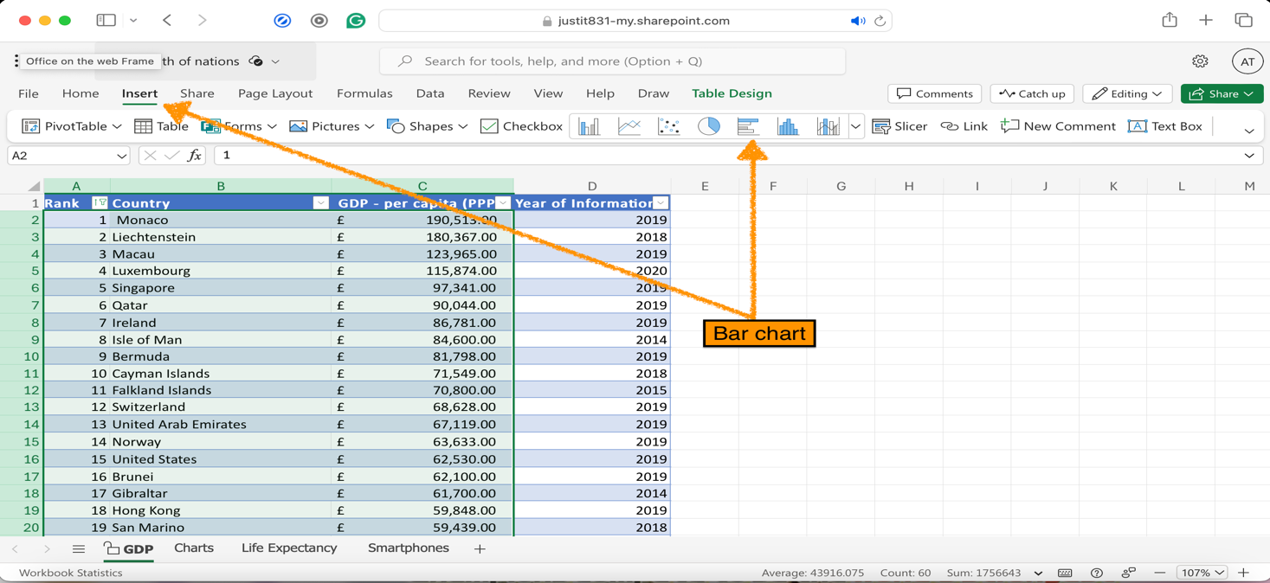

After highlighting the data, from the Insert tab – a bar chart was produced.

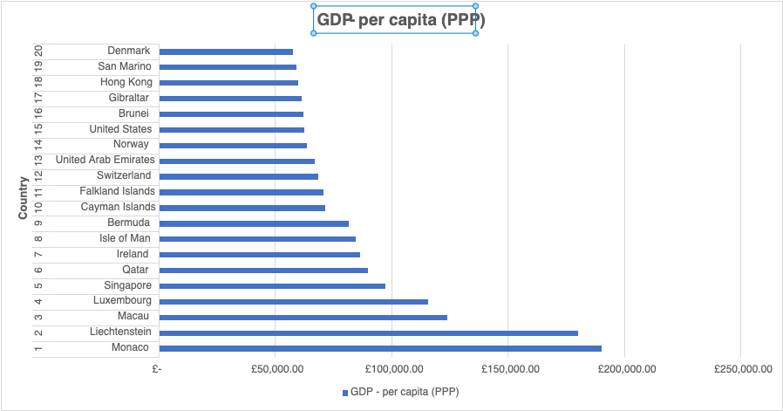A bar chart displaying the 20 highest ranking countries alongside their respective GDP – per capita (PPP).

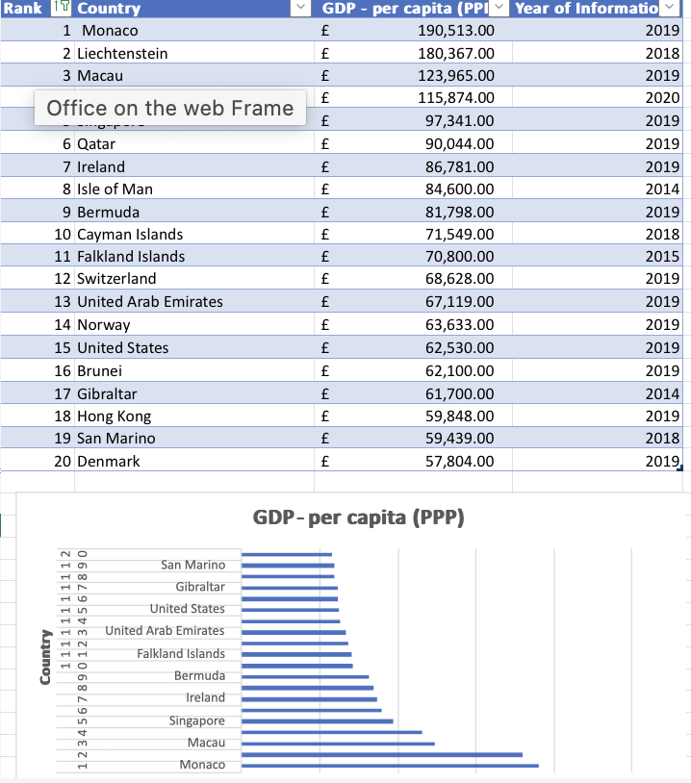

Here, the bar chart is shown as being placed underneath the table as per the assignment instruction.

10.

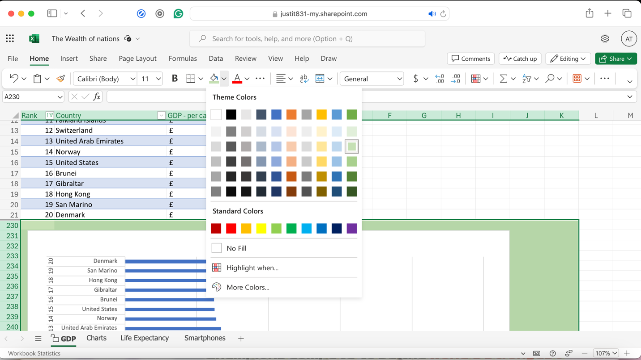

Highlighting the area below the table; behind the chart, the background was coloured using the fill colour option.

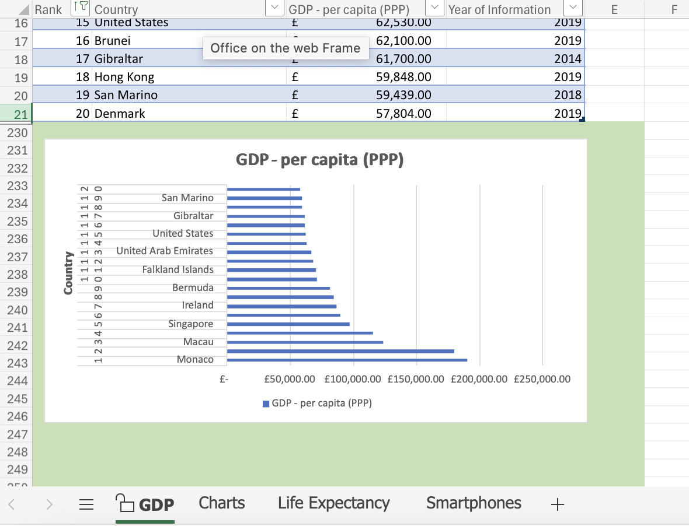

## Reference

* What is a data governance policy? examples + templates (no date) Segment. Available at: https://segment.com/data-hub/data-governance/policy/ (Accessed: 01 August 2024).